Table 1. Demographic data about the groups of students participating in Study 1A, 1B and 2.
Study | N | Number of: |  | Age
Study | N | Women | Men | Mean | std. dev.
1A | 58 | 18 | 40 | 22,57 | 3,24
1B & 2 | 66 | 21 | 45 | 22,29 | 2,90
Source: authors’ own study.

Figure 1 DAX index time series. Red dots represents the timing of study 1A, while the green line – study 2B
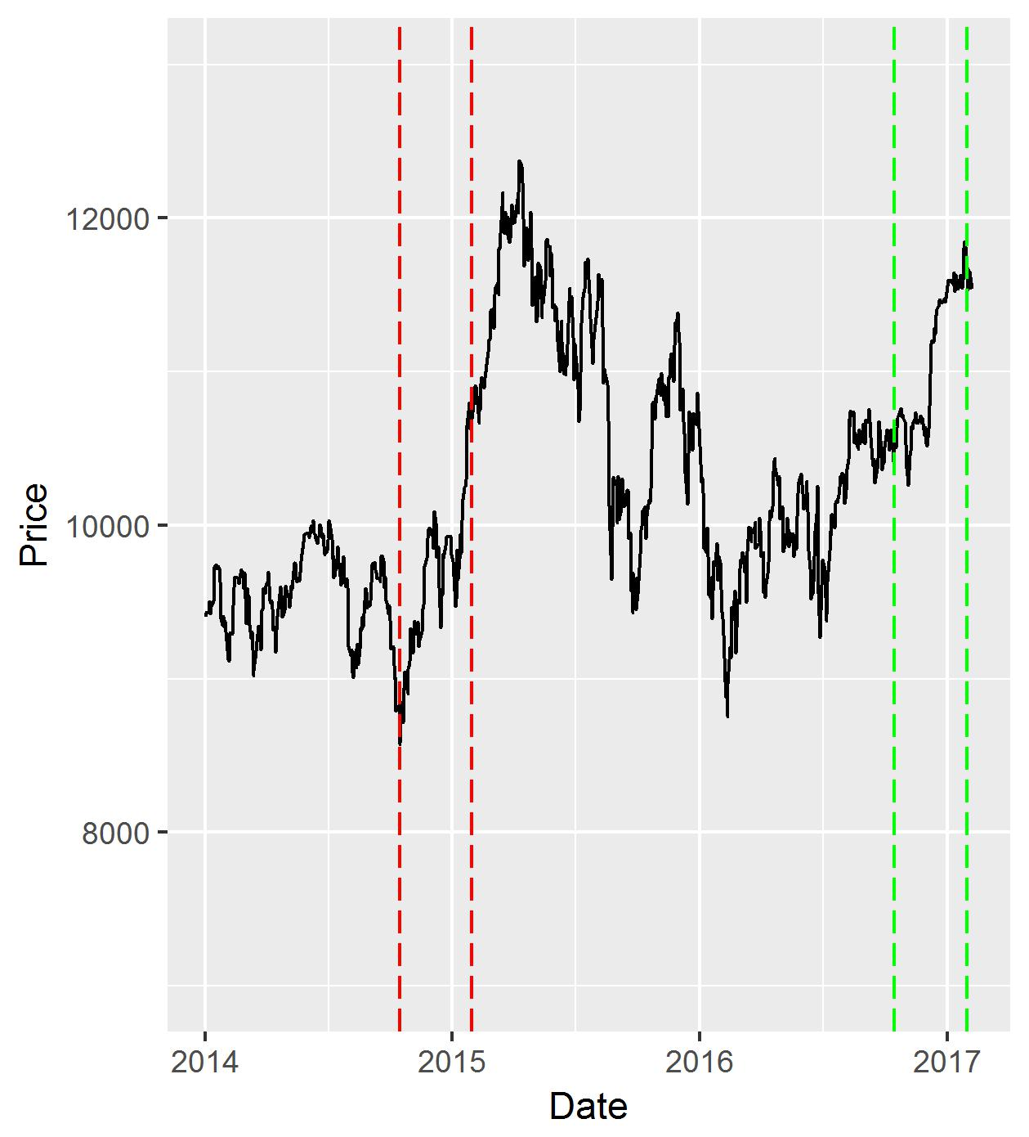

Figure 2 WIG index time series. Red dots represents the timing of study 1A, while the green line – study 2B
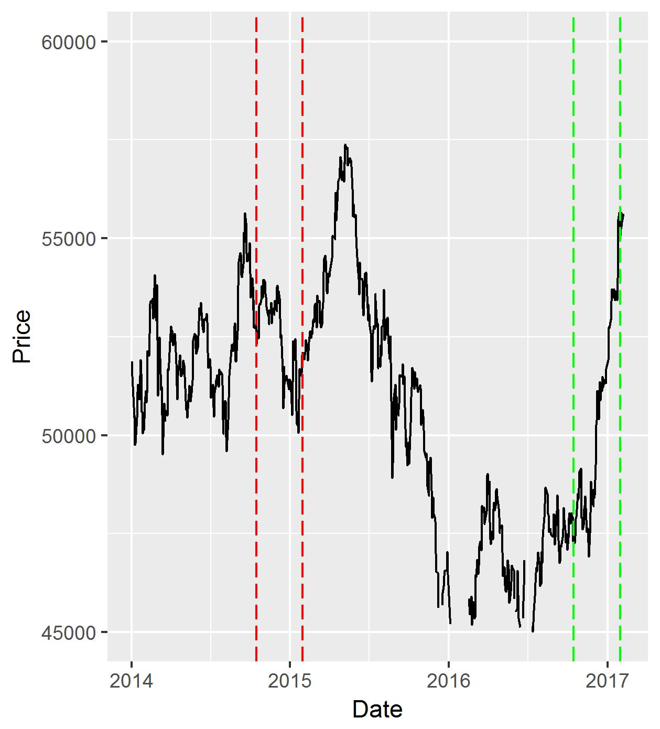

Figure 3 Example of the time series presented to the students in Study 2
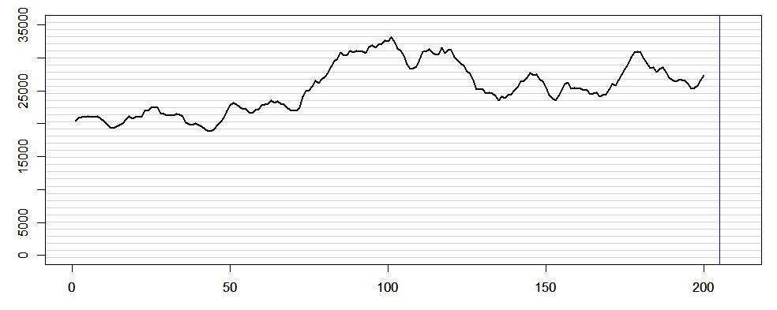

Table 2 Correlation of: absolute values of correlation coefficients between observed trend and forecasted value (RR), the period of the trend considered in forecasting (PER.), average time used for preparation of forecasts (TIME) and the psychological trait measured by Need for Cognitive Closure subscales tests (preference for order and structure OP, desire for predictability FP, discomfort with ambiguity MI, close-mindedness CC, decisiveness BD) for Study 1A.
Study  1A | DAX |  |  | WIG |  |  | OP | FP | MI | CC | BD
Study  1A | RR | PER. | TIME | RR | PER. | TIME
RR | 1 | 0,07 | 0 | 1 | 0 | 0,14 | -0,22 | -0,17 | -0,18 | 0,09 | 0,14
PER. | 0,07 | 1 | -0,1 | 0 | 1 | 0,17 | 0,04 | -0,14 | -0,1 | 0,07 | 0,11
TIME | 0 | -0,1 | 1 | 0,14 | 0,17 | 1 | -0,02 | 0,01 | -0,03 | -0,14 | 0,04
OP | -0,22 | 0,04 | -0,02 | -0,2 | -0,09 | -0,02 | 1 | 0,6 | 0,47 | -0,17 | -0,02
FP | -0,17 | -0,14 | 0,01 | -0,24 | -0,05 | 0,01 | 0,6 | 1 | 0,64 | 0,03 | -0,14
MI | -0,18 | -0,1 | -0,03 | -0,19 | -0,01 | -0,03 | 0,47 | 0,64 | 1 | -0,18 | -0,16
CC | 0,09 | 0,07 | -0,14 | -0,14 | 0,04 | -0,14 | -0,17 | 0,03 | -0,18 | 1 | 0,25
BD | 0,14 | 0,11 | 0,04 | -0,17 | 0,16 | 0,04 | -0,02 | -0,14 | -0,16 | 0,25 | 1
Legend: Significant values of correlation coefficient are bold (p-value<0,05). Source: authors’ own study.
Table 3. Correlation of: absolute values of correlation coefficients between observed trend and forecasted value (RR), the period of the trend considered in forecasting (PER.), average time used for preparation of forecasts (TIME) and the psychological trait measured by Need for Cognitive Closure subscales tests (preference for order and structure OP, desire for predictability FP, discomfort with ambiguity MI, close-mindedness CC, decisiveness BD) for Study 1B.
Study  1B | DAX |  |  | WIG |  |  | OP | FP | MI | CC | BD
Study  1B | RR | PER. | TIME | RR | PER. | TIME
RR | 1 | -0,04 | 0,2 | 1 | 0 | 0,1 | 0,13 | 0,02 | 0,1 | -0,16 | 0,15
PER. | -0,04 | 1 | -0,22 | 0 | 1 | 0,12 | 0,03 | 0,12 | -0,07 | -0,06 | 0,07
TIME | 0,2 | -0,22 | 1 | 0,1 | 0,12 | 1 | 0 | -0,09 | 0,06 | -0,03 | -0,29
OP | 0,13 | 0,03 | 0 | 0,21 | -0,01 | -0,05 | 1 | 0,55 | 0,42 | -0,13 | 0,12
FP | 0,02 | 0,12 | -0,09 | 0,02 | -0,1 | -0,2 | 0,55 | 1 | 0,52 | -0,05 | -0,04
MI | 0,1 | -0,07 | 0,06 | 0,25 | -0,25 | 0,07 | 0,42 | 0,52 | 1 | -0,06 | -0,25
CC | -0,16 | -0,06 | -0,03 | 0,03 | -0,11 | -0,07 | -0,13 | -0,05 | -0,06 | 1 | 0,11
BD | 0,15 | 0,07 | -0,29 | -0,08 | 0,09 | -0,3 | 0,12 | -0,04 | -0,25 | 0,11 | 1
Legend: Significant values of correlation coefficient are bold (p-value<0,05). Source: authors’ own study.
Table 4. One sided pvalues of estimated correlation coefficients between absolute values of correlation coefficients between observed trend and forecasted value and Need for Cognitive Closure subscales tests (NFC) for studies 1A and 1B.
Study | preference for order and structure OP | desire for predictability FP | discomfort with ambiguity MI | close-mindedness CC | decisiveness BD
1A | 0,0443 | 0,0561 | 0,0796 | 0,3413 | 0,169
1B | 0,1081 | 0,9553 | 0,0894 | 0,5202 | 0,3424
Source: authors’ own study.
Table 5. Number of local optima (minimum or maximum) for different parameters of the Alexander filter as well as total rate of return in the period considered.
Exp | 20% | 10% | 5% | 2,5% | RR
1 | 4 | 9 | 18 | 22 | 0,29
2 | 4 | 7 | 21 | 29 | -0,5
3 | 2 | 7 | 17 | 44 | 0,08
4 | 7 | 9 | 9 | 19 | -1,12
5 | 2 | 8 | 13 | 31 | 1,08
6 | 2 | 6 | 14 | 34 | 0,01
7 | 4 | 10 | 14 | 26 | 0,05
8 | 4 | 8 | 12 | 26 | 0,92
9 | 2 | 9 | 17 | 33 | -0,35
10 | 4 | 8 | 13 | 21 | -0,73
11 | 4 | 7 | 19 | 27 | 0,28
12 | 1 | 5 | 11 | 32 | 0,29
13 | 7 | 15 | 23 | 45 | 1,05
14 | 5 | 16 | 24 | 34 | 1,36
15 | 7 | 17 | 33 | 57 | 0,35
16 | 7 | 15 | 23 | 45 | 1,05
17 | 5 | 16 | 24 | 34 | 1,36
18 | 7 | 17 | 33 | 57 | 0,35
19 | 7 | 15 | 23 | 45 | 1,05
20 | 5 | 16 | 24 | 34 | 1,36
21 | 7 | 17 | 33 | 57 | 0,35
Source: authors’ own study.

Table 6. Correlation of: absolute values of correlation coefficients between observed trend and forecasted value (RR), the period of the trend considered in forecasting (PER.), average time used for preparation of forecasts (TIME) and the psychological trait measured by Need for Cognitive Closure subscales tests (preference for order and structure OP, desire for predictability FP, discomfort with ambiguity MI, close-mindedness CC, decisiveness BD) for Study 2.
Study 2 | sideway trend |  |  | up or down trend |  |  | OP | FP | MI | CC | BD
Study 2 | RR | PER. | TIME | RR | PER. | TIME
RR | 1 | 0,02 | 0,23 | 1 | 0,64 | -0,14 | -0,02 | -0,44 | -0,11 | -0,03 | 0,15
PER. | 0,02 | 1 | 0,3 | 0,64 | 1 | -0,04 | 0,51 | 0,17 | 0,2 | 0,2 | -0,11
TIME | 0,23 | 0,3 | 1 | -0,14 | -0,04 | 1 | 0,22 | -0,12 | 0,1 | 0,11 | -0,29
OP | -0,02 | 0,51 | 0,22 | 0,2 | 0,27 | 0,28 | 1 | 0,56 | 0,42 | -0,15 | 0,14
FP | -0,44 | 0,17 | -0,12 | -0,09 | 0,04 | 0,09 | 0,56 | 1 | 0,53 | -0,07 | -0,06
MI | -0,11 | 0,2 | 0,1 | -0,05 | -0,01 | 0,28 | 0,42 | 0,53 | 1 | -0,06 | -0,25
CC | -0,03 | 0,2 | 0,11 | -0,07 | 0,02 | 0,1 | -0,15 | -0,07 | -0,06 | 1 | 0,05
BD | 0,15 | -0,11 | -0,29 | 0,48 | 0,49 | -0,18 | 0,14 | -0,06 | -0,25 | 0,05 | 1
Legend: Significant values of correlation coefficient are bold (p-value<0,05). Source: authors’ own study.

