Charts 2 – 6. Macroeconomic stability pentagon divided into European regions between 2006-2015 – modified classic scale
Chart 2. EU28 Chart 3. Western Europe Chart 4. Central and Eastern Europe

Chart 5. Southern Europe Chart 6. Poland
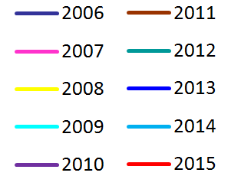
Source: Own calculations based on Eurostat data, http://ec.europa.eu/eurostat (accessed: 11.03.2017).

