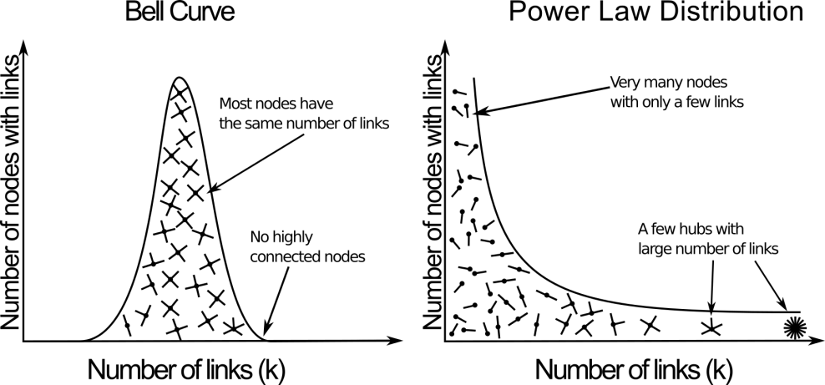

Figure 1
======================================================================
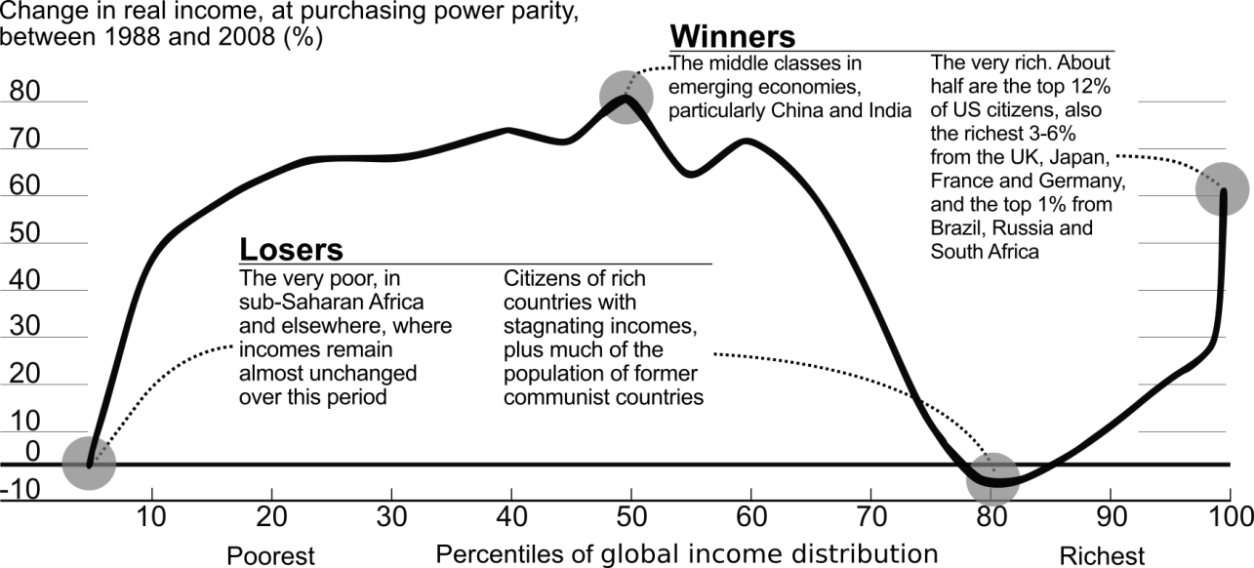

Figure 2
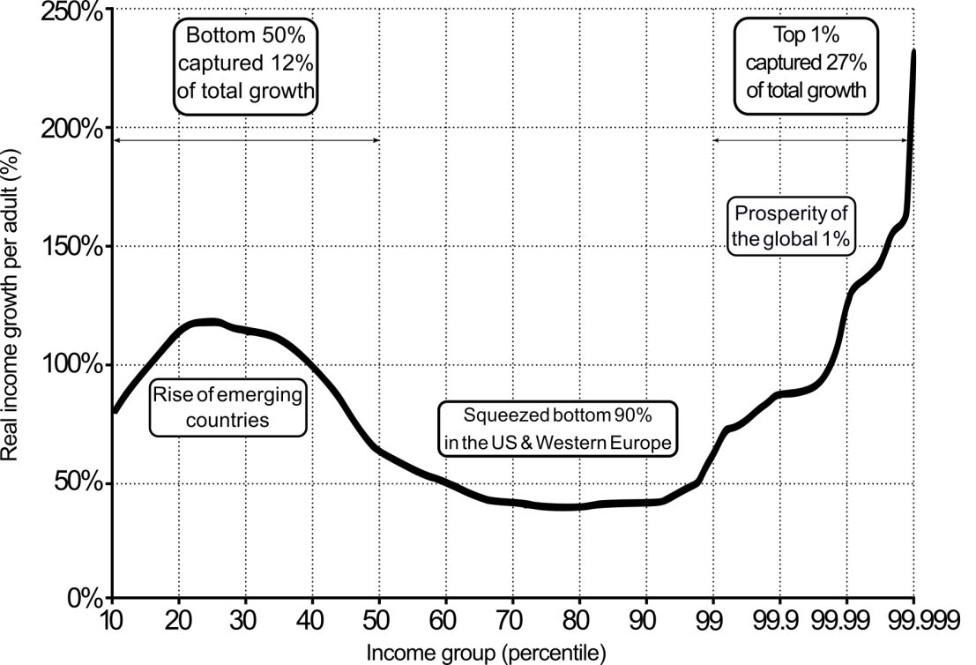

Figure 3.
Table 1
 | Total cumulative real growth per adult
Income group | China | Europe | India | Russia | USA-Canada | World
Full population | 831% | 40% | 223% | 34% | 63% | 60%
Bottom 50% | 417% | 26% | 107% | -26% | 5% | 94%
Middle 40% | 785% | 34% | 112% | 5% | 44% | 43%
Top 10% | 1316% | 58% | 469% | 190% | 123% | 70%
Top 1% | 1920% | 72% | 857% | 686% | 206% | 101%
Top 0.1% | 2421% | 76% | 1295% | 2562% | 320% | 133%
Top 0.01% | 3112% | 87% | 2078% | 8239% | 452% | 185%
Top 0.001% | 3752% | 120% | 3083% | 25269% | 629% | 235%

Table 2
Income group | China | Europe | India | Russia | USA-Canada | World
Full population | 100% | 100% | 100% | 100% | 100% | 100%
Bottom 50% | 13% | 14% | 11% | -24% | 2% | 12%
Middle 40% | 43% | 38% | 23% | 7% | 32% | 31%
Top 10% | 43% | 48% | 66% | 117% | 67% | 57%
Top 1% | 15% | 18% | 28% | 69% | 35% | 27%
Top 0.1% | 7% | 7% | 12% | 41% | 18% | 13%
Top 0.01% | 4% | 3% | 5% | 20% | 9% | 7%
Top 0.001% | 2% | 1% | 3% | 10% | 4% | 4%

