Chart 1. Quarterly U.S. Current Account and Component Balances
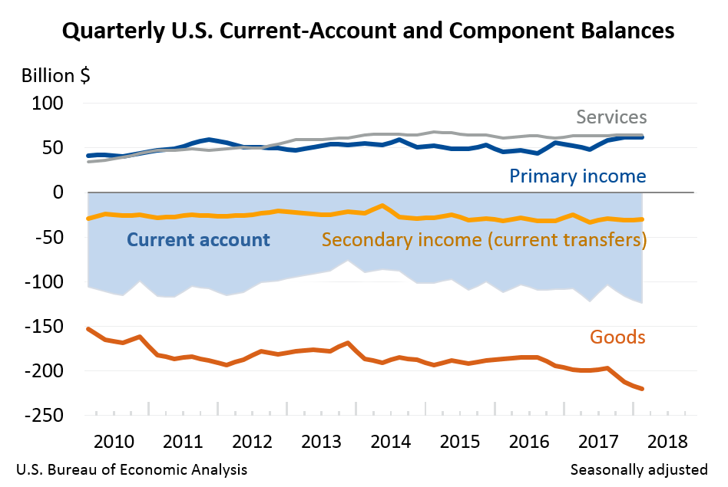

Source: The US Bureau of Economic Analysis (SCB 2018).

Chart 2. Macroeconomic impact in the United States from imposing tariffs on imported goods
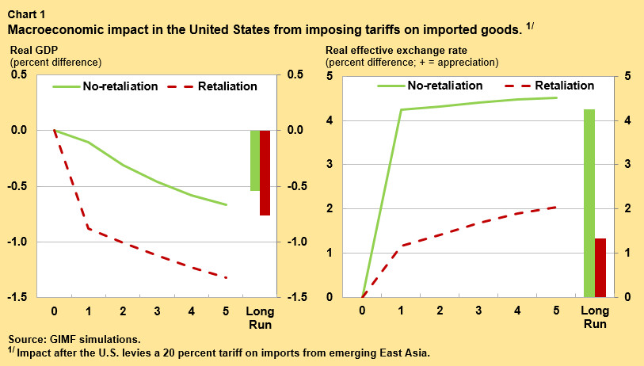

Source: Simulations using the Global Integrated Monetary and Fiscal Model (Obstfeld 2018).

Chart 3. Impact on United States trade from imposing tariffs on imported goods
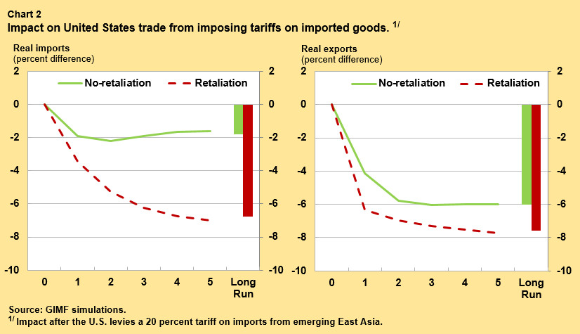

Source: Simulations using the Global Integrated Monetary and Fiscal Model
(Obstfeld 2018).

