 | World Population |  |  |  |  | World GDP
 | 1600 | 1700 | 1820 | 1900 | 1950 | 1600 | 1700 | 1820 | 1900 | 1950
China | 28.8 | 22.9 | 36.6 | 25.6 | 21.6 | 29.0 | 22.3 | 33.0 | 11.1 | 4.6
India | 24.3 | 27.3 | 20.1 | 18.2 | 14.2 | 22.4 | 24.5 | 16.1 | 8.6 | 4.2
Africa | 9.9 | 10.1 | 7.1 | 7.0 | 9.0 | 7.0 | 6.9 | 4.5 | 3.4 | 3.8
Latin America | 1.5 | 2.0 | 2.1 | 4.1 | 6.5 | 1.1 | 1.7 | 2.2 | 3.6 | 7.8
Western Europe | 13.3 | 13.5 | 12.8 | 14.9 | 12.1 | 19.8 | 21.8 | 22.9 | 34.2 | 26.2
Western Offshoots | 3.0 | 3.1 | 3.5 | 5.5 | 7.0 | 0.3 | 0.2 | 1.9 | 17.6 | 30.7
Eastern Europe | 3.3 | 3.1 | 3.5 | 4.5 | 3.5 | 2.8 | 3.1 | 3.6 | 5.2 | 3.5
Former USSR | 3.7 | 4.4 | 5.3 | 8.0 | 7.1 | 3.4 | 4.4 | 5.4 | 7.8 | 9.6
Japan | 3.3 | 4.5 | 3.0 | 2.8 | 3.3 | 2.9 | 4.1 | 3.0 | 2.6 | 3.0
TOTAL | 100 | 100 | 100 | 100 | 100 | 100 | 100 | 100 | 100 | 100
Table 1: Distribution of Population and GDP in the World Economy: 1600-1950 (in %).
Source: Maddison, 2003, 1998; Nayyar, 2013:13-15.

 | GDP |  |  | GDP per capita
 | 1820-1870 | 1870-1913 | 1913-1950 | 1820-1870 | 1870-1913 | 1913-1950
The West
West Europe | 1.68 | 2.12 | 1.19 | 0.99 | 1.34 | 0.76
Western Offshoots | 4.31 | 3.92 | 2.83 | 1.41 | 1.81 | 1.56
Eastern Europe | 1.41 | 2.33 | 0.86 | 0.63 | 1.39 | 0.60
Former USSR | 1.61 | 2.40 | 2.15 | 0.63 | 1.06 | 1.76
Japan | 0.41 | 0.44 | 2.21 | 0.19 | 1.48 | 0.88
The South
China | -0.37 | 0.56 | 0.04 | -0.25 | 0.10 | -0.56
India | 0.38 | 0.97 | 0.23 | 0.00 | 0.54 | -0.22
Africa | 0.75 | 1.32 | 2.56 | 0.35 | 0.57 | 0.90
Latin America | 1.22 | 3.52 | 3.39 | -0.04 | 1.86 | 1.41
Table 2: Growth Rates in the World Economy by Regions: 1820-1950 (in % per annum)
Source: Nayyar, 2013, p.22; Maddison, 2003, 1998.

 |  | 1978 – 2015
Rank | Country | Total increase  1978-2015 | Average annual growth | Growth compared to United States
1 | China | 1,396% | 7.4% | 461%
2 | Myanmar | 660% | 5.2% | 326%
3 | South Korea | 632% | 5.1% | 319%
4 | Taiwan | 566% | 4.8% | 299%
5 | Vietnam | 484% | 4.4% | 272%
6 | Thailand | 443% | 4.1% | 256%
7 | India | 431% | 4.0% | 251%
8 | Sri Lanka | 430% | 4.0% | 251%
9 | Singapore | 418% | 3.9% | 246%
10 | Cambodia | 394% | 3.8% | 235%
11 | Hong Kong | 382% | 3.7% | 230%
12 | Malaysia | 369% | 3.6% | 224%
13 | Indonesia | 346% | 3.4% | 213%
14 | Chile | 330% | 3.3% | 204%
15 | Mozambique | 293% | 2.9% | 184%
For comparison
39 | United States | 180% | 1.6% | 100%

Table 3: Per Capita GDP – fastest growing economies from 1978 to 2015.

Source: Calcualted from the Conference Board Total Economy Database 2015; World Bank, 2016.

Country | Total growth 1978-2015 | Annual average growth | Growth rate as % of China | 1978 – per capita GDP as % of China | 2015 – Per capita GDP as % of China
Japan | 182% | 1.6% | 22% | 2,078% | 275%
Germany | 177% | 1.6% | 21% | 2,625% | 340%
UK | 189% | 1.7% | 23% | 2,123% | 298%
France | 156% | 1.2% | 16% | 2,465% | 286%
US | 180% | 1.6% | 22% | 3,010% | 404%
China | 1,396% | 7.4% | - | - | -

Table 4: Total per capita GDP growth in advanced economies, 1978-2015.

Source: Calcualted from the Database 2015; World Bank, 2016.

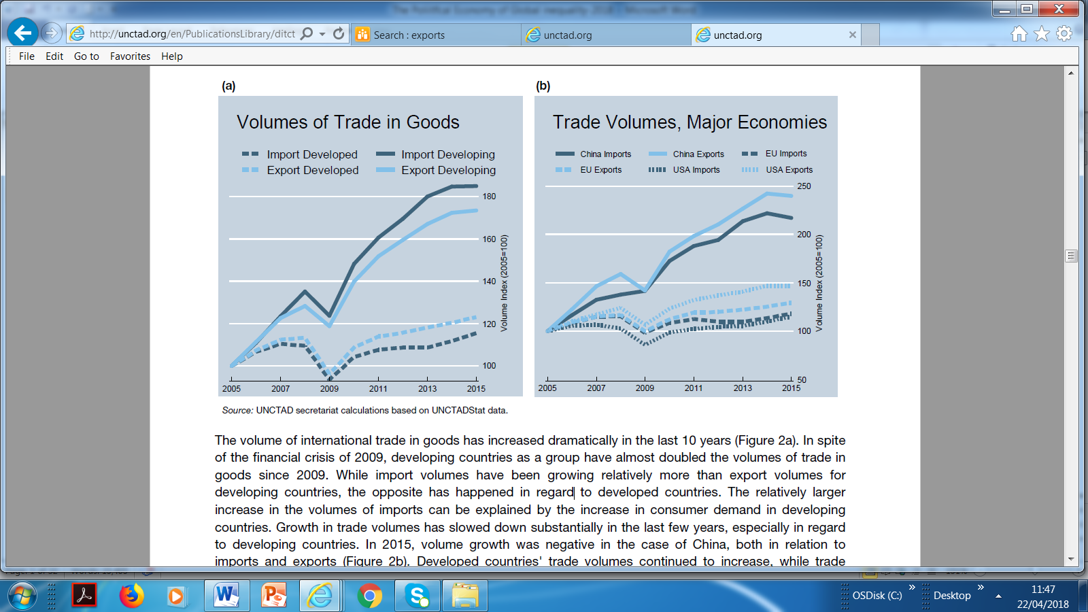
Figure1: Volumes of International Trade in Goods
Source: UNCTAD, Key Statistics and Trends in International Trade, 2016.
http://unctad.org/en/PublicationsLibrary/ditctab2016d3_en.pdf. (accessed on 20 April 2018)

