Table 1. The experimental data.
No. | $$X_{1}$$ | $$X_{2}$$ | $$X_{3}$$ | $$Y$$
1 | 2000 | 90 | 100 | 225
2 | 1800 | 94 | 95 | 212
3 | 2400 | 88 | 110 | 229
4 | 1900 | 91 | 96 | 222
5 | 1600 | 86 | 100 | 219
6 | 2500 | 96 | 110 | 278
7 | 3000 | 94 | 98 | 246
8 | 3200 | 90 | 100 | 237
9 | 2800 | 88 | 105 | 233
10 | 3400 | 86 | 97 | 224
11 | 1800 | 90 | 100 | 223
12 | 2500 | 89 | 104 | 230
Source: Montgomery D. C. [2001], Design and Analysis of Experiments, John Wiley & Sons, Inc., New York

Figure 1. Normal Q-Q plot for residuals of model (18)
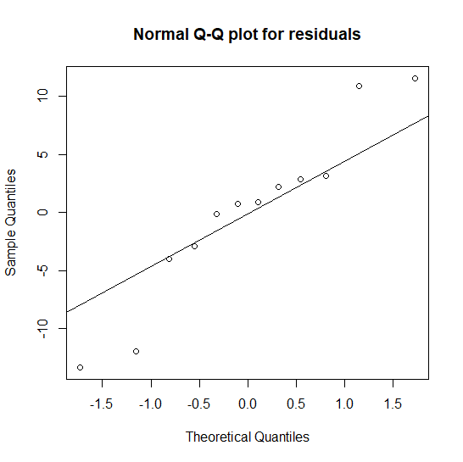
Source: the author’s own elaboration

Table 2. The results of testing significance of response surface function (18).
Parameter | Estimate | Standard Error | t - value | p - value
$$β_{0}$$ | -266.03 | 92.674 | -2.871 | 0.021
$$β_{1}$$ | 0.017 | 0.004 | 2.390 | 0.044
$$β_{2}$$ | 3.135 | 0.844 | 3.712 | 0.006
$$β_{3}$$ | 1.867 | 0.535 | 3.494 | 0.008
Source: the author’s own elaboration

Table 3. The values of $\hat{ASL}$.
Parameter | $\hat{ASL}$ - value
$$β_{0}$$ | 0.078
$$β_{1}$$ | 0.030
$$β_{2}$$ | 0.005
$$β_{3}$$ | 0.008
Source: own elaboration

