Can Global Imbalances Continue? The State of the United States Economy
- Introduction
This study critically examines the structural causes of economic imbalances, focussing on the high current account deficit of the United States. Evaluating whether this current account imbalance is good or bad for the global economy requires an understanding of the underlying characteristics of the US as an advanced capitalist economy which provides markets for the savings of surplus countries. This function is seen by critics as unsustainable in the long term and sometimes as the main factor causing uncertainty and hindering growth in the global economy (Wade, 2017; Wolf, 2008a).
The US has been running deficits on its current account since the early 1990s. The deficit fell below zero in the Clinton Administration, then rose under the George W. Bush Administration and has followed an upward trend since. Current account deficits and surpluses have caused dislocations in both developing and advanced economies. The IMF’s (International Monetary Fund) External Sector Report (2018b) estimates that 40-50% of global current account imbalances are now excessive, with the largest excessive deficits being concentrated in the US and the UK. The IMF defines “excessive” as “not explained by countries’ fundamentals and desirable policies (emphasis added).”
As long as a country runs a current account deficit, it must sell assets to the rest of the world in order to finance a portion of its imports and international income payments. The IMF (2018a) warns that, “Because of the risk that foreign lending dries up, deficit countries face greater pressure to balance their international accounts than surplus countries do to balance theirs. But when the adjustment comes, both debtor and creditor countries lose. The adjustment in the aftermath of the global financial crisis is a not-too-distant reminder of that.” The policy approach recommended by the IMF to deficit countries includes fiscal consolidation, reducing the generosity of pension systems, and market reforms to labour costs – measures that seem likely to be politically inflammatory in countries already long subject to relative stagnation (or decline) in incomes, demographic ageing, growing private households debt, and decline in the quality of basic infrastructure.
Unsurprisingly, after years of austerity measures of the type the IMF recommends, the capacity of the capitalist system to achieve stability, prosperity and peace through self-regulation is being called into question by both professional economists and the public at large (Wolf, 2018a).
We will also discuss the impact of Covid-19 pandemic on the US economy. To understand the adverse impact of the corona pandemic on the economy, we need to analyse its effect on different industries. Consumption makes up 70% of the US GDP, but consumption has dropped as businesses close and as households postpone about major purchases as they worry about their finances and their employments. In the US, investment makes up 20% of GDP, but businesses are postponing future investment as they wait for full picture of the corona. Tourism music, sports, entertainment, and restaurants constitute 4.2% of GDP. With restaurants and film theatres are closed and the manufacturing sector constitute nearly 11% of the GDP, but most of this is now disrupted, because global supply chains industries and companies have shut down in anticipation of reduced demand.
According to the IMF forecast, the US economy will shrink by almost 6% this year, compared with a contraction of about 7% in the EU countries and 5% in Japan, while the other experts estimated an annualised second-quarter decline in the US could be as much as 40%. However, if the government were not spending several trillion US dollars to keep businesses afloat, wages to unemployed and benefits to poor sections of the society, the damage would be worse. Over three months has passed since national lockdown was declared in US to limit the spread of Covid-19, during which time it has become clear that the country is also heading for its deepest recession since the ‘Great Depression’.
The US and UK governments have pumped trillions of dollars into their economies and have reduced interest rates to combat recession. For instance, the UK government has launched a job retention scheme to pay up to 80% of the workers’ wages. Nearly 400,000 companies have applied to pay nearly 3 million people through furlough payments, which have cost the UK government £2 billion until now. There is also a similar scheme to compensate five million self-employed workers. Unfortunately, many millions will not be covered under such plans. For businesses, the government has provided up to £300 billion of loans although few of these have so far been awarded by the banks responsible for processing them.
This study will examine global imbalances in historical perspective to better understand the current situation. First, we note that these global imbalances have been defined as “external positions of systemically important economies that reflect distortions or entail risks for the global economy” (Brake et al, 2010). This definition, which accords with the view of the IMF, outlines important features of global imbalances and indicates that the inner disequilibria of large advanced economies could be of relevance to the rest of the world. It has been argued that the US current account deficit cannot be remedied through a temporary nominal deflation of the US dollar alone and that it will also require some strong policy measures to address the domestic imbalances in the US economy (De Cecco, 2012).
Some mainstream economists see current account imbalances not as a source of potential instability but rather the result of emerging markets’ objective of increased accumulation and export led growth (Taibbi, 2018; De Cecco, 2012). They argue that global imbalances should not be a source of concern. After the 1997 East Asian crisis most of those countries felt a strong desire to raise their US dollar reserve holdings sharply. However, as a result, substantial US dollar reserves haveled to allocative inefficiency through net transfer being made from low-to high-income countries. This phenomenon is known as Lucas’ Paradox.
Under this economic situation Keynes (1980) argued that in fact a greater burden lies on surplus countries: “The objective of the new system must be to require the chief initiative from the creditor countries, whilst maintaining enough discipline in the debtor countries to prevent them from exploiting the new ease allowed them in living profligately beyond their means” (Keynes, 1980:30). Keynes famously argued in his book The General Theory of Employment, Interest and Money (1936/1973) that the main concern during the Great Depression was to take capitalism out of crisis, which required government regulation of the market. During such a crisis, consumption and investment have to be increased and if private investment is lacking then government has to take the initiative. Keynes also favoured regulation of financial markets. For Keynes, the main cause of the economic crisis was lower investment. If capitalists increase the level of investment, leading to an increase in GDP, then recession can be averted. Critically, however, because capitalists aim merely to raise profits and accumulate wealth this can be achieved either by raising productivity or by cutting wages, the latter leading to lower aggregate demand and a reduction in production capacities.
The increased financialisation of the past three decades and stagnation in the labour share of national income in the advanced economies are together largely responsible for rising inequality in income distribution because they decouple improvements in the personal income of households from improvements in macroeconomic performance (ILO, OECD, 2015). Financial investments – largely speculation – continue to grow at a faster rate than growth in GDP and investment in real production. However, in an era of declining investment in the real economy this rapid growth in speculative financial investment requires and demands higher levels of debt from households. (Armstrong and Siddiqui, 2019)
The global financial crisis of 2008 illustrated the inability of capitalism driven by neoliberal policies to resolve the contradictions of this new economic environment. The monetary system under the neoliberal model has contributed to global financial instability and has ultimately adversely affected the global economy. For developing countries, who rely heavily on trade and capital inflows for their economic growth the failure of the global reserve system to provide sufficient international liquidity during the crisis highlighted their vulnerability to economic forces beyond their control. (Patnaik and Patnaik, 2016; World Bank, 2017)
The research question is as to why in recent years the US economy has created these huge deficits. The methodology of this study is chosen carefully in order to answer the research question. The research method of this study is based on analysing the data provided by the international institutions and published reports and also intends to critically examine the relevant studies in order to answer the research question.
The US households have also accumulated huge debts to finance their consumption. On these issues Wolf notes: “[A]ny country that receives a huge and sustained inflow of foreign lending runs the risk of a subsequent financial crisis because external and domestic financial fragility will grow… Cheap money encouraged an orgy of financial innovation, borrowing and spending” (Wolf, 2008a:13).This is, however, an incomplete account because the mortgage-backed securities and the derivatives based on them, which were the ultimate cause of the 2008 financial crash, were dependent on higher levels of indebtedness by “miserable victims” who largely “turned out to be poor, non-white, and elderly” (Taibbi, 2018).
Certainly, easy access to money can induce people to borrow and spend but there are also other forces influencing their spending and consumption decisions. Marketing, in particular, seems to be playing an increasingly crucial role in sales. Many corporations spend a tremendous amount of money to promote and sell their products and under monopoly capitalism this trend has risen sharply. As Baran and Sweezy (1966) have pointed out under monopoly capitalism, price competition is replaced by product differentiation and the building of a loyal consumer base. Multi-national corporations allocate huge amounts of money for advertising, marketing and the development of large ranges of different products. At the same time capital came to depend on the support of its country of origin to defend its interests and also to provide help against rivals. According to Baran and Sweezy, the growing interdependence of states and capitalists has given rise to an intensification of geo-political rivalries that could lead to armed conflict. The recent clash between the US and France over the latter’s plan to tax Google, Amazon and other tech giants is illustrative. (BBC News Online, 2019)
In fact, the present level of advertising is much greater in the US than other advanced economies. For example, total advertising expenditure in the US is greater than the sum of the other advanced economies such as UK, France, Germany, Holland, Italy, Spain and Japan. The constant bombardment through marketing and advertising increases the psychological and social pressures on people to buy more. It is well known that consumer demands are not endogenous but shaped by exogenous institutional processes and especially by corporate advertising. Indeed, although rational choice theory has not been abandoned the relatively new discipline of behavioural economics has placed much more emphasis “on the ways in which consumer decision-making may not be fully rational and how firms can exploit such consumers” (Fatas & Lyons, 2013). Moreover, under oligopolistic markets, such as those we find in US tech industries, intense rivalry and competition can easily lead to high investment in product innovation and differentiation.
The period of relative global stagnation and instability in which capitalism finds itself is evidenced by slow growth rates. The world economy has been growing at around 3.3% annually since 2008, compared to 4.5% in the earlier decade. Much of global growth between the years 2009 and 2018 has been due to growth in China, which was stimulated by government investment in infrastructure (Siddiqui, 2020a; Sahoo et al., 2010). Indeed, China has become a significant global economic power in recent years, while the US and European countries have witnessed relatively little growth. However, China still cannot adequately counter the effect of stagnation and lack of demand from major advanced economies.
A recent study by Bullard et al (2017) points out that although the US economy is still the world’s largest, between 2008 and 2016, there was an average 20% annual shortfall in fixed capital investment, which has adversely impacted GDP growth and output. Despite this relative lack of growth the US still functions as a major source of demand for the global economy, thereby pulling much of the rest of the world economy. Indeed, since the early 1980s, the current account deficit of the US has risen to very high levels. This has no doubt benefited China, India, (Siddiqui, 2018a) and a few other emerging economies but did not benefit the majority. Germany has also followed the mercantilist approach, which focuses on exports, and as a result the country has been running the largest surplus of any economy in the world since 2010. This policy has suppressed domestic wages and demand, despite increases in productivity. (Jason, 2015)
Since the global financial crisis of 2008, the world economy has not seen consistent growth comparable to that of earlier decades; rather output recovery has been limited and fragile. Moreover, the recent employment increase in the US and Europe has not reduced inequality nor has it sustained meaningful wage increases for the majority. Global capitalism and its economic system have been unable to deliver steady growth and prosperity for nations and at the same time persistent attacks against trade unions together with unbalanced fiscal policy have reduced workers’ bargaining power. (Siddiqui, 2019a) In the US 24% of adult workers now derive income from the gig economy and for 44% of these individuals such work is their primary source of income (Edison Research, 2018). It is not an exaggeration to argue that the creativity of early capitalism has been superseded by a new era typified by insecure employment, private debt, financial speculation, declining innovation, stagnant aggregate demand, and government-assisted asset price inflation.
- The Political Crisis of Global Capitalism
The question arises as to whether the United States will remain the leader of global capitalism after the current political and economic crisis has run its course. It appears that Donald Trump’s orientation toward protectionism will be constrained by the global production chains of US corporations and that high technology industries will very likely escape the effects of tariff adjustments. There are, however, other considerations.
The Chinese economy is now the world’s second largest. China is also the second largest global trader and currently holder of the largest amount of foreign exchange reserves. In recent years, the Chinese economy has accounted for more than one-fifth of incremental demand worldwide. Furthermore, China’s ability to use its economic power to bring about transformations in global governance has become a serious research endeavour within Chinese academia (Xueliana and Lu, 2016). Moreover, some other fast growing developing economies have also boosted global demand and these countries are similarly questioning their future role in the global order vs.-á-vs. both the US and China (Beeson and Zeng, 2018).
The emerging economies have built up massive foreign exchange reserves mainly to defend themselves from panic capital withdrawals, as was witnessed during the 1997 East Asian crisis and again after the 2008 financial crisis. Such sudden withdrawal of capital proved to be costly in terms of their investment, economic growth and overall development (IMF, 2010). Flexible exchange rates and free capital movements have thus been unable to keep the world economy stable.
Will capitalism overcome and resolve the conflicts caused by the globalisation of modern technology? Early in the 20th Century Rudolf Hilferding noted in his famous work Finance Capital (1910) that the emergence of finance capital under monopolies could be seen as a new form of capitalism in which the separation between industrial capital and finance capital - a key characteristic of competitive capitalism - disappears. According to Hilferding, under this new phase capitalism seems is better organised and no longer subject to production anarchy and periodic economic crises. Monopolies will be able to plan, produce and distribute and thereby eliminate overproduction crises in commodities. Similarly, Karl Kautsky (1970) believed that better organisation in production could eliminate inter-imperialist wars. However, he found challenges unresolved between agriculture and industry. Kautsky saw that production and capital accumulation were much faster in industry than agriculture and that this could lead to increased investment in the former, resulting in tension between these two sectors. In the 20thCentury two World Wars and the Great Depression proved that Hilferding and Kautsky were over-optimistic. Moreover, recent optimistic trends such as the reductions in arms spending and military conflict after the collapse of the Soviet Union proved unsustainable (SIPRI, 2019).
Robinson (2004) argues that modern capitalism has transformed itself hugely due to the rise of transnational capital and integration of countries into regional cooperation. In this new global financial system, despite the existence of national capital, a new transnational capitalist class has emerged and risen to domination globally. As a result competition occurs among global corporations and not between countries: “As nation states are captured by transnational capitalist forces, they tend to serve the interests of global over local accumulation processes” (Robinson, 2004:17). In fact, imperialism has the intrinsic need to export capital in order to reduce costs and seek higher profits (Patnaik and Patnaik, 2016). These capital exports also lead to increased competition among countries. International corporations can operate in several regions and globally but still they always need to remain linked to their home country where they can receive legal protection and support (Kobrin, 2009). Neoliberalism as a set of economic policy measures gives more power to those institutions which can further increase their control over surplus. It also systematically propagates the view that the market is the only efficient way to carry out economic activity.
- The US Economy and Global Imbalances
The US current account deficit, which is the ultimate cause of key global imbalances, has been said to be due to overspending in the US, though some blame ‘policy exchange rates’ adopted by surplus countries to prevent currency appreciation. Figure 1 indicates the US current account balances for 2011- 2020. According to this alternative view, if exchange rates were flexible then surplus countries’ currencies would appreciate against US dollar until the imbalances are removed (Siddiqui, 2020b). Such arguments blame surplus countries directly for the problem of US deficits. The US dollar still accounts for two-thirds of all foreign exchange reserves and thus the ability of the United States to run large current account deficits could be a calamity should it prove impossible to maintain stability of the global capitalist system in the face of internal dysfunction, climate emergency, and renewed competition for global economic, political, and military hegemony. (Willett and Chiu, 2012)
Former Chair of the US Federal Reserve Ben Bernanke’s ‘saving-glut’ theory argues that US overspending caused US trade deficits, (see Figure 2) due to this money flowing back into the US market from other countries through its capital account. This leads to credit expansion and lower interest rates making it attractive for US consumers to overspend, and as a result US household consumption increases global demand. Here it is being emphasised that US trade deficits give rise to excessive global savings which need to be addressed first because otherwise reducing global imbalances by raising US savings would lead to a global slump and recession (Siddiqui, 2019b). Bernanke has also argued that high saving rates in surplus countries, especially in East Asian countries, were due to historical, cultural and demographic factors. Others have pointed out that East Asian crisis in 1997 has been an important reason for such behaviour. Some also emphasise that global excessive savings are due to structural causes and will not be corrected simply by these measures (Wade, 2017).
The continuous rise in foreign reserves in foreign countries leads to an increase in demand for US financial assets, which are regarded as the global safe asset. The seemingly ever-rising inflow of funds into the US financial system from abroad encourages asset price inflation, while excessive reserve accumulation overseas is due to efforts by developing economies to self-ensure against possible speculative currency attacks. (Siddiqui, 2019c) These countries are cautious and guarding against sudden investment collapse, capital flight or domestic currency appreciation as these could adversely affect export competitiveness and economic stability.
Figure 1: Current Account Balance – Total, % of GDP, Q12011-Q12020.

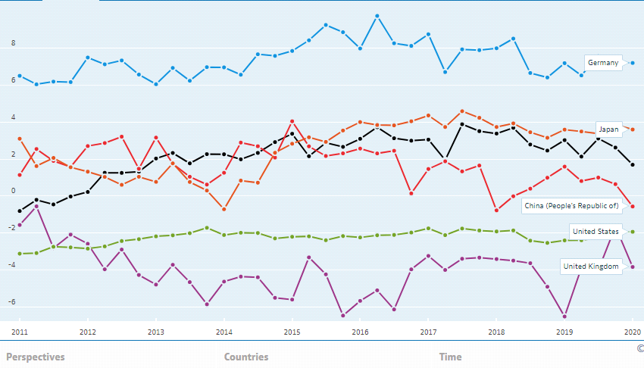

Source: OECD. (Accessed on 18 July 2020)
https://data.oecd.org/trade/current-account-balance.htm#indicator-chart

Source: OECD. (Accessed on 18 July 2020)
https://data.oecd.org/trade/current-account-balance.htm#indicator-chart

Figure 2: Trade in Goods and Services, Exports as % of GDP, 1991-2019.
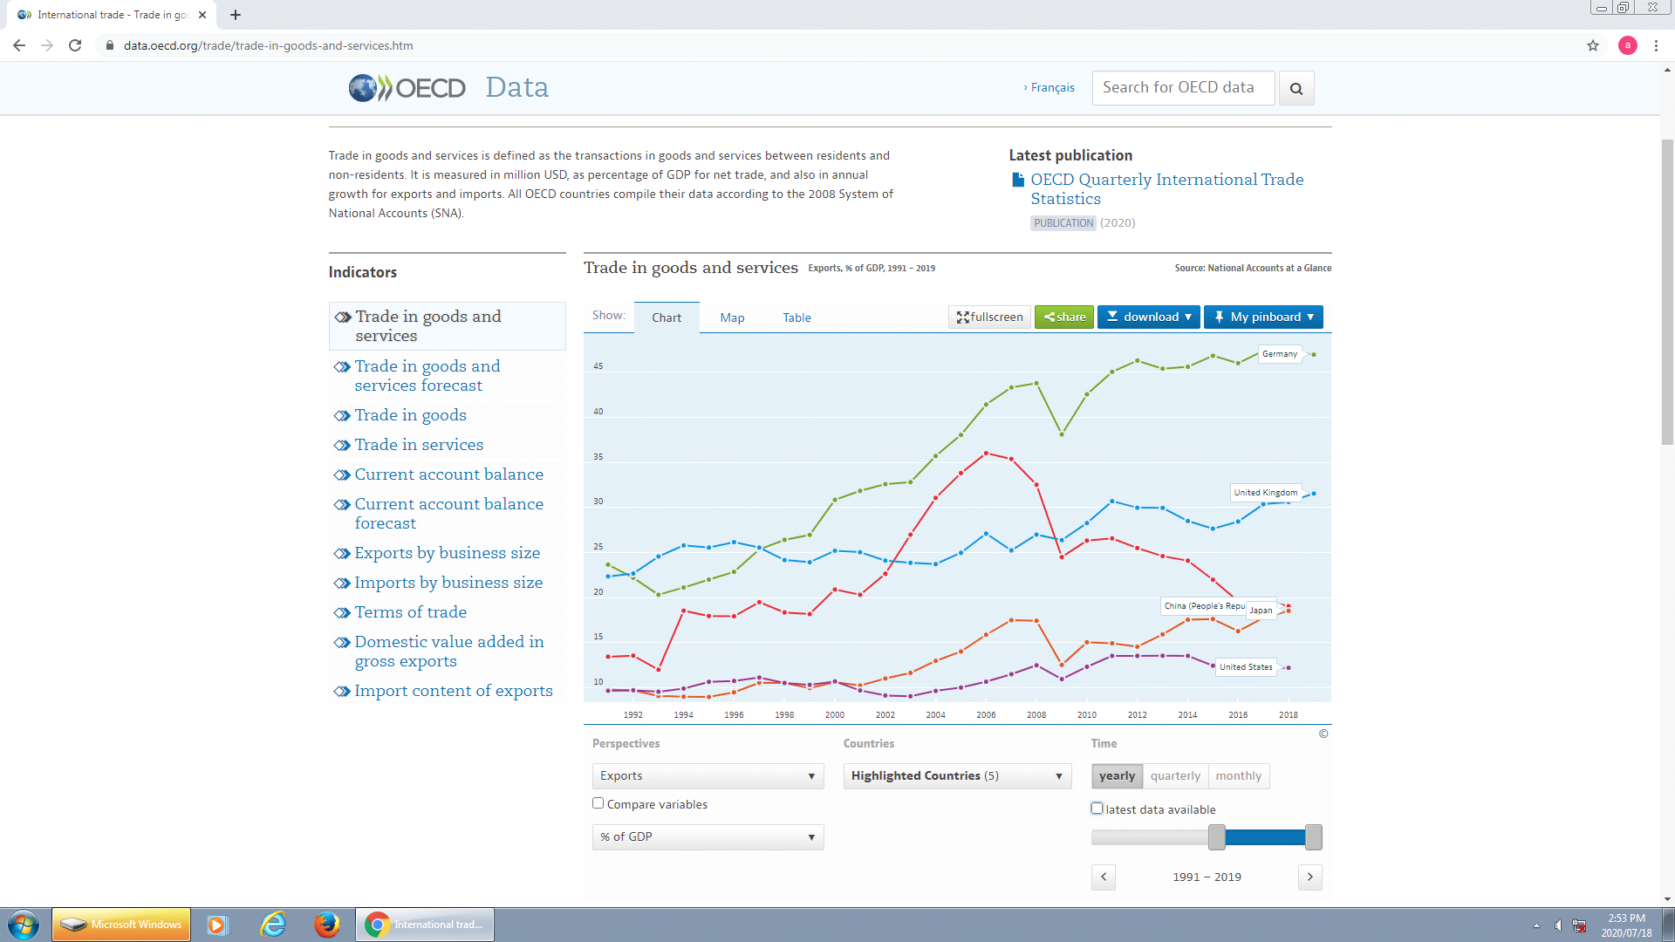

Source: OECD. (Accessed on 18 July 2020)
https://data.oecd.org/trade/trade-in-goods-and-services.htm#indicator-chart
Source: OECD. (Accessed on 18 July 2020)
https://data.oecd.org/trade/trade-in-goods-and-services.htm#indicator-chart.
Historically, very large current account deficits are in fact sustainable for very long periods of time. During the late 19th century there was a very large and sustained current account imbalance in the UK, which was then exporting a huge amount of capital to Australia, Canada and Argentina. Some critics were worried that UK investors were lending and exporting capital while neglecting domestic markets and, in fact, this capital was exported from the UK primarily because of the lack of higher returns in the domestic economy.
Factor income was very important before the First World War, when Britain was called a nation of rentiers. At this time, Britain’s current account was dominated by foreign dividend inflows, which were the yield of past investments. In the 1920s, Britain became a deficit country and its huge foreign investments were used to pay for war supplies imported from the US. By then, the US was the main surplus country and also held most of the world’s gold.
Now US economic growth is low by historical standards with only a 2.3% GDP increase in 2017. In 2016, US economic growth was 1.5%, while EU growth was 2% and China’s growth was 6.7% for the same period. The EU’s average growth was 2.5%, and China’s was 6.9%. There seems to be a strong correlation between US output growth and the percentage of net fixed investment in the US, meaning that over the long term it is not possible for the US economy to accelerate without an increase in net fixed investment. For example, in 1966, during the long term boom, US net fixed investment was 11.3% of GDP, but in 1978 it was 10.5%, in 1984, 9.2%, in 1999, 8.3%; in 2006, 7.9%; in 2017, 4.2% and in 2018, 5.1%. The US fixed capital formation remains far below not only the post-war period but also below the financial crisis of 2008. (OECD, 2020)
Donald Trump’s tax cuts for US corporations and the wealthy, which have not been matched by government spending reductions, will sharply increase the US budget deficit. If other things remain the same this will reduce US domestic savings and therefore reduce domestic US capacity to finance investment. It will also increase the federal deficit and will push up bond yields to attract foreign buyers. However, although the US share of global GDP is now estimated at less than 20%, US-based companies control about half of the world’s wealth. These facts show us a very complex picture of the contemporary world economy.
The current crisis in the US is a product of the structural crisis of capitalism, evidenced by stagnation, financialisation, monopolisation, and environmental crisis. (Siddiqui, 2019a) The structural crisis in which growth does not lead to productive job creation or job security has been building for decades. These developments have brought about crises of the liberal-democratic state. Neoliberalism, which has almost certainly reached its limits, is further raising inequalities within the advanced economies thus giving rise to extremist tendencies which threaten liberal democracy itself. In the US these conditions are more visible with the decline of US hegemony in the world economy (Bello, 2006).
The relative decline of the US as a global economic power can be seen in the economic statistics. The US is undoubtedly in a less powerful position than in the past decade with respect to production and productivity (Siddiqui, 2020c). However, it is still successfully siphoning off much of the economic surplus created in the developing countries with the help of US-based, big corporations and its hegemony of global finance (Siddiqui, 2019a). With respect to US financial dominance, the key issue becomes the survival of the dollar as the hegemonic currency. This is certainly facing challenges at present by the rise of China, but even so the US has by far the largest defence spending and military power in the world. The country has maintained supremacy mainly through the role played by its defence sector in technological advancement. But all of this will be difficult for the US to maintain due to a relative decline of its economic position in the world. However, a smooth transition to a multi-polar world is far from guaranteed, and tensions between rivals are evident. Periods of hegemonic instability in the capitalist world economy in the past have been periods that gave rise to wars and to fascism in the last century.
China’s market reform in 1978 created an alliance with global capital, by making China the world hub for the global labour arbitrage of multinational corporations, which shifted their production platforms to China in order to exploit low labour costs and to achieve economies of scale. In fact, the Chinese government has used its share of the proceeds to promote urban development at a frenetic pace and to provide infrastructural development that further facilitated multinational corporations doing business there and enhanced their profits. China’s huge migrant labour population has provided a reserve army of labour that has kept wages low (Siddiqui, 2016).
Despite these developments, the current recovery in the US is fragile because it is a product of the expansion of the global financial system of the previous decades. As capital develops, money cannot find a ready outlet and moves into interest bearing capital. In recent decades interest bearing capital has expanded magically as it receives vast interest payments.
Financialisation has been described in terms of the dominance of finance over industry. (Wien, 2010) This does not mean that finance is controlling or dictating to the industrial sector (Siddiqui, 2019b). In fact studies have shown that in the advanced economies corporations are relying less upon the financial sector to fund their operations. Moreover, in the US, for instance, non-financial corporations are themselves increasingly moving into financialisation and are thus deriving a share of their profits from their financial rather than from their productive activities. As Martin Wolf has described it, “The US itself looks almost like a giant hedge fund. The profits of financial companies jumped from below 5 percent of total corporate profits, after tax, in 1982 to 41 per cent in 2007” (Wolf, 2008b).
The expansion of credit generally has helped both to conceal and to defer capitalism’s problems in the period from the early 1980s, as part of a system sometimes dubbed “privatised Keynesianism”, but only at the expense of creating a grotesquely oversized and unstable financial system that would ultimately explode into crisis that remains without a clear solution.
Soon after the 2008 financial crisis, the Federal Reserve, the Bank of England and the European Central Bank launched quantitative easing programmes or, in the case of the Bank of Japan, expanded an existing programme. Quantitative easing involves central banks electronically creating money and using it to purchase assets from banks and other financial institutions, in particular acquiring government bonds. Doing so has two effects. First, it floods the banking system with liquidity, supposedly encouraging lending. Second, it drives up the price of bonds. Bonds pay a fixed income at regular intervals, so, if they increase in price, their “yield”, the return on the investment relative to the price, tends to fall. Lower yields mean lower borrowing costs.
Despite the persistence of high levels of sovereign debt in the US, no country is willing to challenge the dollar as the representative international currency. As Patnaik notes, any alternative to the dollar as an international currency will require a country to challenge the status quo. He argues that the fall in the value of the dollar in terms of oil could lead to the decline, and finally replacement, of the dollar. At present, there is no attempt nor, it seems, any interest among major dollar holders or among top major economies to seek an alternative. Currently, the major creditors to the US, namely China, Japan, Germany and oil exporter Middle East countries, rely heavily on the US markets to prop up their own domestic demand. In the US, real wages have fallen since 2008 but domestic demand has continued to grow thanks to household borrowing. Also, external factors have contributed to the decline in manufacturing prices by moving production overseas and thus raising profits (Patnaik, 2009).
The neoliberal model has thus failed to validate the opinion that ‘we must have more globalization’. Another major crisis could be a chance to change economic policy and could lead to the redistribution of wealth and power, benefitting some previously marginalised classes and sectors, while restraining others. For example, decolonisation became possible after the World Wars weakened European ability to brutally control and exploit their colonies; negotiations between employers and employees became the norm, with trade unions playing a greater role in wage negotiations.
The model of capitalism presented by the WTO, IMF and World Bank rests on the fiction that the pursuit of self-interest also promotes the public interest. However, the deepening crisis in the 1970s with rising inflation and unemployment led to the questioning of this belief. And then in the early 1980s, the US assigned an increased role to market forces through privatisation and deregulation. Trade unions and the public sector were attacked systematically. Capital liberalisation and deregulation of the financial sector led to a rapid expansion of this sector. This led to the reversal of the gains of previous decades, especially in income distribution. For instance, in the US the income share of top income group (1%) declined from 29% in 1929 to 8% in 1970 and stayed the same until 1979, while the lower and middle income group experienced a greater rise in their incomes. In contrast, the neoliberal regime pursued since the 1980s has reversed the redistributive policy. For instance, in the US, the income share of the top 1% rose very sharply to 23% by 2008 (Wade, 2017). During the 1990s and 2000s economic expansion was associated with the rapid rise in real-estate prices. However, by 2006 these prices began to stagnate and reached a plateau. Soon after 2007, housing markets plunged into a deep fall in prices resulting in the sub-prime financial crisis and global economic recession. The deflating US real-estate bubble brought down the market value of the new derivative securities, which constituted a large fraction of the assets the banks had accumulated (Kotz, 2018).
The profit rate fell during the 2008 crisis, but after 2013 it rose again, but has slightly fallen again since 2014. The recovery of 2012-14 was associated with debt-financed consumer spending, which was not sustainable in the long run. (Siddiqui, 2019d) The 2014 recovery took place when consumer spending accelerated while investment in the economy slowed; government spending also declined in real terms over the period, exerting an adverse impact on output growth. During this period US imports grew faster than exports, therefore, the biggest factor to have contributed to US GDP growth in recent years is household consumer spending, which contributed 81% of the increase over the period of 2014-17. Investment slowed to 2.1%, contributing only 16% of the GDP growth for the same period (Kotz, 2018). Moreover, the US government’s and firms’ foreign debts exceeded foreign assets by equivalent to 30% of its GDP as early as 2004 (Glyn, 2005).
The question arises as to whether current US protectionism is justified. Therefore, in order to assess this, we will attempt to take a somewhat long-term view regarding the external payments situation of the US. Figure 1 provides a summary of the external sector of the country from just before the breakdown of the Bretton Woods System in 1971.
To understand the situation more clearly, we need to analyse the US trade in goods and services and its current account situation on the basis of available statistics. Figure 3 shows the external sector payments of the US from 1970 to 2017. Apart from a few exceptions, most of the time its current account was negative in goods. However, in the late 1980s the service sector gained a surplus and was steadily rising. Despite these changes, this rise in service exports was unable to fill the gap created by the general trade imbalance in goods. Moreover, since 2014, service exports have stagnated. The US trade deficit kept on rising, and has grown remarkably over the last two decades. This was coincident with the period when China joined WTO, which appears to have given the US an excuse to blame China for raising its trade deficits. The US trade deficit with China and other countries are shown in Figure 4 & 5.
Figure 3: Trends in United States’ External Payments ($ billions), 1970-2017.
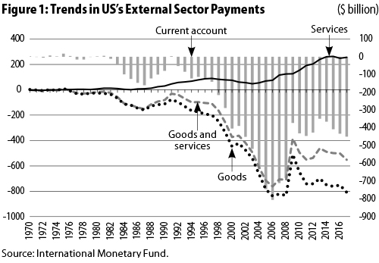

Source: International Monetary Fund (IMF), 2018.

Figure 4: United States – China Trade in Goods (1985-2017)
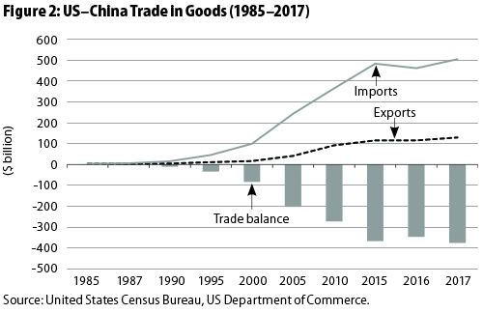

Source: US Census Bureau, US Department of Commerce. 2018.
Figure 4, which shows the trade in goods between the US and China, indicates that the US has had trade deficits in goods with China since the early 1990s, which has grown substantially. For example, the deficit was only US$10 billion in 1990, but by 2000 had reached US$100 billion; by 2005 it had risen further to US$200 billion, by 2012 it was US$315 billion, and by 2017 it had reached US$376 billion. The sharpest rise was since 2001, which also coincided with China joining the WTO. For example, China’s exports to the US increased from US$125 billion to US$505 billion, while US exports to China increased only US$19 billion to about US$130 billion for the same period.
Figure 5: United States’ Trade Deficit with all Trading Partners, 1985-2017.

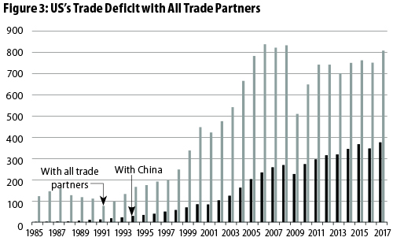
Source: US Census Bureau, US Department of Commerce. 2018.
To what extent is China responsible for the US’s rising trade deficit? To answer this, we need to examine US trade performance with the other major trading partners. Figure 3 indicates that China is an important trading partner for the US, but that China still has less than half of the US’s overall trade deficits. For example, in 2017 the US’s trade deficit with China was US$375 billion, however, its overall trade deficit was US$775 billion. This means that even if the US were to eliminate its trade deficit with China, its trade imbalance problems would still exist.
China is largely facilitating the final assembly stages of global production networks of vertically integrated high-tech industries. To explore the magnitude and patterns of trade arising from cross-border production networks, it is necessary to separate parts and components from final assembled products traded within global production networks.
In fact, US trade imbalances are largely self-inflicted. The US needs to address factors within its economy rather than blaming others. Trade deficits (i.e., imports exceeding exports), reflect the saving-investment gap in terms of national income, which is associated with low levels of domestic saving rates (Siddiqui, 2018b). Most economists and policy makers have barely touched on this important issue, namely that consumption has risen while saving rates have declined, or otherwise remained low. For example, the US domestic savings rate was never higher than 24% in the 1950-60s, but for the last two decades it has steadily declined and is now below 17% (McBride, 2017). Personal savings as a proportion of disposable income in the US have fallen from an average of 10% between 1975 and 1985 to around 5% by 1995 and to only 0.7% in 2010. At the same time the debt of US households has risen sharply.
There are serious structural weaknesses in the US economy, which need to be addressed. Blaming its trading partners might be convenient for the US in the short term, but will certainly not be effective in the long term. President Donald Trump, rather than addressing the structural crisis, has taken the initiative to cut corporation tax and increase tariffs, which seems to be short term relief that will at the same time boost imports. In 2002, during the Bush administration, higher tariffs were imposed on imported steel and aluminium, but rather than helping, this adversely affected the automotive and construction industries, which are amongst the largest employers in the US.
The United States has witnessed a decade of slow growth, low investment, and low productivity, all of which have been further marked by increased debt. All of these factors have contributed towards higher current account deficits. Further, by raising import tariffs, the US has violated the WTO’s multilateral trade rules which, ironically, were negotiated under the leadership of the United States.
To compare the current US situation with that of Britain soon after the First World War: Britain had sold most of its foreign assets and had tried to bring back Gold Standard without sufficient gold reserves and with a weak current account. This ended in dramatic failure. But there are crucial differences between 1920s Britain and the current US position. The US is still the largest economy in the world and the US severed the dollar link to gold in 1971 since when it can only be converted into other national currencies. Despite the US current account deficit since 1982, none of the surplus countries have attempted to sell the dollar on a large scale in order to reduce global imbalances.
The US has decided to have a strong currency, as did Britain in the 19th century, in order to reduce inflationary pressures, to attract foreign assets, and to boost the country’s financial markets. Due to higher wages and strict environmental regulations within the US, companies - especially in labour-intensive industries– have decided to relocate to countries where wages and taxes are low. As a result, manufactured imported goods have gradually replaced domestically produced ones, resulting in the imbalances discussed in this paper.
- The Covid-19 and the US economy
In order to understand COVID-19’s impact on the US economy, we need to consider its effect on different industries. Consumption makes up 70% of America’s GDP, but consumption has slumped as businesses close and as households hold off on major purchases as they worry about their finances and their jobs. Investment makes up 20% of GDP, but businesses are putting off investment. Arts, entertainment, recreation, and restaurants constitute 4.2% of GDP. With travelling, hotels, film theatres and museum are closed. Another important sector, namely Manufacturing makes up 11% of US GDP, but much of this is disrupted, because global supply chains have been obstructed by factory closures and because companies are shutting down factories in anticipation of reduced demand. Ford and GM, for example, have announced temporary closures of car factories.
With the businesses closures, layoffs have already started. Small businesses will especially struggle to keep staff on the payroll as their revenue slumps. Countries such as Germany are taking steps to help companies and avoid being laid off and the US would be wise to do so as well. The U.S. Congress has passed a massive stimulus bill that provides for hundreds of billions in new spending, expanding unemployment insurance and providing a cash handout to low and middle-income groups, which should help those who lost jobs to meet their basic consumption needs. The legislation also provides for $350 billion in “loans” for businesses, targeted at firms with fewer than 500 employees.
Unemployment is shooting up far faster than it did during the 2008 recession, a sign the economy is headed toward recession. How long is the COVID-19 slump likely to last?
It seems that the ongoing coronavirus pandemic will haunt the US economy for a decade, wiping close to $8 trillion off economic growth, according to new projections released by the Congressional Budget Office (CBO) in mid-July. Since the pandemic hit the US trillions of dollars have been poured into the economy via government stimulus programs and actions by the Federal Reserve. However, such measures still have not stopped unemployment soaring to levels unseen since the 1930s By early July this year nearly 40 millions have lost their jobs and the it is expected that the unemployment rate may reached 20% in end of July, up from 15.3% in June, which rose from 4.4% in March this year. It is estimated that by end of July 2020, the world output has a yearly projection of -4.9% (IMF) -5.2% (World Bank) and -6% (OECD). In worst-case scenarios, the latter two organizations foresee contractions of -8 and -7.7%, respectively. The International Monetary Fund anticipates that the United States will contract by -8.0% while China will observe a growth of 1.0%. The Euro Zone and Latin America are to contract by -10.2 and -9.4%, respectively.
With the deepening economic crisis, the neoliberal policy about the imperative of ‘fiscal austerity’ and the limitations of public policy has vanished. The businesses are asking for government spending and the portentous preachers of the ‘free market’ rush to the TV screens to plead for increased public spending. The pandemic hit after four decades of neoliberalism had depleted state capacities in the name of the ‘superior efficiency’ of the market, fostered deindustrialization through the ‘globalization’ of production.
The question is how bad will the downturn become? And how soon will the economic recovery begin? Will the recession be double dip, also known as W-shaped downturn, i.e., drop twice before it recovers to its previous growth rate, or more like an L-shaped scenario, otherwise known as a ‘depression’ i.e., a deep recession with no recovery for several years, just as Japan witnessed since the early 1990s (Siddiqui, 2015a). All indicators tell us so far that the crisis is going to deepen and will most likely resemble the L-shaped scenario. We should not expect a return to business as usual.
Last week the IMF warned that the world economy is facing its worst recession since the ‘Great Depression’ of the 1930s with output likely to fall sharply by as much as 6.5% in 2020. Gita Gopinath, the IMF's chief economist, said the crisis could knock US$ 9 trillion (£7.2 trillion) off global output within the next two years. (See Figure 6 & 7) For all of us who lived through the Asian Financial Crisis of 1997, these warnings will bring back stark memories of currency crashes, property prices tumbling and millions out of work and the wealth that was built up in decades disappearing in a matter of months. The covid-19 pandemic economic crisis will be even worse - our generation's Great Depression. (Siddiqui, 2020d)
Figure 6: Annual Growth of the GDP in Major Advanced Economies.
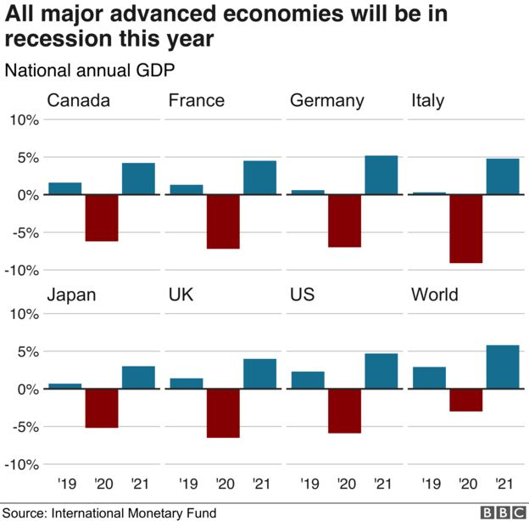
Source: IMF, https://www.bbc.co.uk/news/topics/c77jz3mdmxxt/international-monetary-fund-imf (Accessed on 12th May 2020).
Figure 7: Fiscal Measures Announced in G20 Economies, % of GDP.
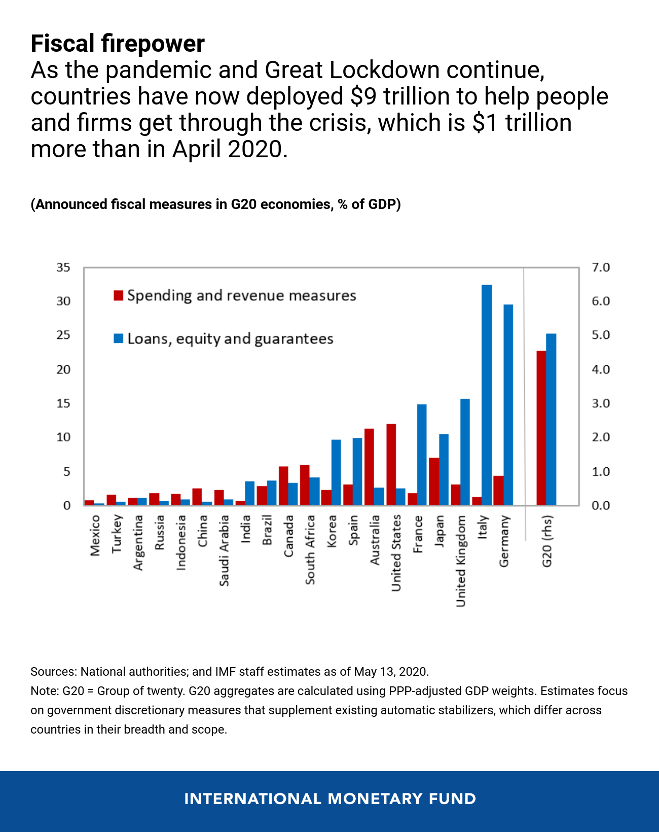

Source: IMF, 2020. https://outlook.office365.com/mail/inbox/id/(Accessed on 22 May 2020)
The IMF says governments must help these households and firms survive because the impact of the coronavirus will be "severe, across the board and unprecedented". The IMF also predicts that the annual growth of the emerging economies will fall sharply (see Figure 3). The Fund said this scenario could trigger a downward spiral in heavily-indebted economies. It said investors might be unwilling to lend to some of these nations, which would push up borrowing costs. In fact, only a few countries in the world have that sort of financial power to deal with this. Many are grappling with huge populations, limited financial resources, and the very real possibility of political instability as their people get sick, hungry or both.
- Conclusion
This historical account indicates that a high current account deficit is not necessarily intrinsically harmful. There are, however, features of the current situation that have the potential to exacerbate negative trends and to further fuel adverse economic and political outcomes. The US current account deficit stems in part from growth of the financial sector and from its creation of complex and unstable financial derivatives built on risky forms of private debt. Furthermore, this “financial innovation” has itself been a response to the low growth and low profitability of the domestic productive economy (Norfield, 2012).Despite the clear warnings provided by the 2008 banking and subsequent sovereign debt crises US corporate debt is at an all-time high and in 2017 “the value of securities issued based on car loans, credit card debt, student loans and various other unsecured debt exceeded commercial and residential mortgage-backed securities combined” (Blakeley, 2019).
The economic risks of the current situation are being compounded by the political approach of the Trump Administration, which characterises US trade partners as adversaries in need of coercion through tariffs and strident rhetoric. So far these policies have succeeded only in further depressing the profitability of US business (Amiti et al, 2019).Additionally, Trump’s rejection of the post-war liberal international order in favour of “transactional bilateralism” (Stokes, 2018) suggests that a coordinated, US-led international response to a future global recession could be even more deficient than the current response to climate change.
The Covid-19 pandemic has triggered the sharpest and deepest contraction of GDP (Gross Domestic Product) in the history of capitalism as globalisation has gone into reverse. International supply chains, which were once the exemplars of organised production and the backbone of trade, have collapsed; an emphasis on the national economy is back. Overseas travel and tourism have almost stopped entirely. Within the last few weeks, tens of millions of workers have become unemployed and millions of small businesses and their suppliers have closed down. The world’s highest official coronavirus death tolls have been seen in two countries, namely the United States and the United Kingdom. This was unexpected because both of these countries had time to prepare after warnings from scientists and cautionary examples from China and Italy. Moreover both countries have a strong research base, access to vast resources, and millions of scientists, engineers, and medical professionals, yet were still unable to deal with the pandemic effectively.
Finally, although the IMF and other institutions of global governance have now questioned the effectiveness of neoliberal policies (Ostry et al, 2016), the severe measures the IMF advocates in response to current account deficits could presage yet another era of anti-growth austerity measures in both the United States and the United Kingdom. The burden of these will undoubtedly fall on those least able to bear the strain, nationally and internationally. The possibility that harsh and anti-egalitarian measures could further inspire aggressively nationalist and generally anti-progressive political movements in these countries– and throughout the world – should not be discounted. In the meantime surplus and deficit countries alike must navigate the uncertain terrain between the current global hegemonic power, its potential rival and global institutions that function on principles designed for an era of capitalism that ended in 2008.
Declaration of Interest Statement
The authors declare that they have no conflicts of interest with regard to this work.
References:
- Amiti, M., et al. 2019. “The Impact of the 2018 Trade War on U.S. Prices and Welfare,” Discussion Paper, Centre for Economic Policy Research. (Accessed on 1 August 2019). https://www.princeton.edu/~reddings/papers/CEPR-DP13564.pdf.
- Armstrong, P. and Siddiqui, K. 2019. The case for the ontology of money as credit: money as bearer or basis of “value”, Real-World Economics Review, Issue no. 90, pp. 98-119, December.
- BBC News. 2019. “US launch inquiry into French plan to tax tech giants”. (Accessed 31 July 2019). https://www.bbc.co.uk/news/world-europe-48945828.
- Beeson, M., and Zeng, J. 2018. “The BRICS and global governance: China’s contradictory role,” Third World Quarterly, 39:10. https://doi.org/10.1080/01436597.2018.1438186
- Bello, W. 2006. “The Capitalist Conjuncture: Over-Accumulation, Financial Crises, and the Retreat from Globalisation”, Third World Quarterly, 27 (8), 1345-1367.
- Blakeley, G. 2019. “The next crash: why the world is unprepared for the economic dangers ahead,” New Statesman, 6 March. (Accessed on 1 August 2019). https://www.newstatesman.com/politics/economy/2019/03/next-crash-why-world-unprepared-economic-dangers-ahead
- Bullard, S., Silvia, J. E., and Iqbal, A. 2017. “Can We Estimate the Cost of a Recession?” American Economic Association Conference. (Accessed on 6 June 2018).www.aeaweb.org/conference/2017/preliminary/paper/bzQ4bKGK
- De Cecco, M. 2012. “Global Imbalances: Past, Present, and Future”, Contribution to Political Economy, 31:29-50.
- Edison Research. 2018. “The Gig Economy”. (Accessed 5 August 2019). http://www.edisonresearch.com/wp-content/uploads/2019/01/Gig-Economy-2018-Marketplace-Edison-Research-Poll-FINAL.pdf
- Fatas, E., and Lyons, B. (2013), “Consumer Behaviour and Market Competition,” in Behavioural Economics in Competition and Consumer Policy. Centre for Competition Policy, University of East Anglia, UK. http://competitionpolicy.ac.uk/documents/8158338/8193541/CCP+economics+book+Final+digital+version+-+colour.pdf/30214557-cace-4b0b-8aac-a801bbde87bc
- Hilferding. R. 2006. Finance Capital: A Study in the Latest Phase of Capitalist Development, London: Routledge.
- ILO (International Labour Organisation). 2015. “The Labour Share in G20 Economies,” G20 Employment Working Group. (Accessed 5 August 2015). https://www.oecd.org/g20/topics/employment-and-social-policy/The-Labour-Share-in-G20-Economies.pdf
- IMF. 2010. “How Did Emerging Markets Cope in the Crisis?” IMF Working Paper. (Accessed 31 July 2019). https://www.imf.org/external/np/pp/eng/2010/061510.pdf
- IMF. 2018a. “Addressing Global Imbalances Requires Cooperation”. IMF blog post by Maurice Obstfeld. (Accessed on 31 July 2018). https://blogs.imf.org/2018/07/24/addressing-global-imbalances-requires-cooperation/
- IMF. 2018b. External Sector Report. Tackling Global Imbalances Amid Rising Trade Tensions. (Accessed on 31 July 2018) https://www.imf.org/en/Publications/ESR/Issues/2018/07/19/2018-external-sector-report.
- IMF. 2020. https://www.bbc.co.uk/news/topics/c77jz3mdmxxt/international-monetary-fund-imf
- Jason, J. X. 2015. “The Drivers of Current Account Surplus in Germany and the Politics of Rebalancing in the Eurozone.” EU Centre in Singapore Working Paper No. 24. (Accessed 31 July 2019). http://aei.pitt.edu/67355/1/WP24-Germany-and-Politics-of-Eurozone.pdf
- Kautsky, K. 1970. “Ultra-imperialism,” New Left Review, no. 59 (January–February): 41–46.
- Keynes J.M. 1973. [1936]. The General Theory of Employment, Interest and Money, London: McMillan/Palgrave.
- Keynes, J.M. 1980. The Collected Writings of John Maynard Keynes, Volume XXV: Activities 1940-1944: Shaping the Post-War Economy, London: Macmillan.
- Kobrin, S. J. (2009). “Sovereignty Bay: Globalization, Multinational Enterprise, and the International Political Situation”. The Oxford Handbook of International Business (2nd. Edition). (Accessed 31 July 2019). http://dx.doi.org/10.1093/oxfordhb/9780199234257.003.0007
- Kotz, D. 2018. “End of the Neoliberal Era?” New Left Review, 113, 29-55. September-October. https://newleftreview.org/issues/II113/articles/david-kotz-end-of-the-neoliberal-era
- Lee, Jong-Wha. 2014. “Will the Renminbi Emerge as an International Currency?” The World Economy, 37(1): 42-62, January. https://doi.org/10.1111/twec.12092
- McBride, J. 2017. “The US Trade Deﬁcit: How Much Does It Matter?,” Council on Foreign Relations, 17 October. https://www.cfr.org/backgrounder/us-trade-deficit-how-much-does-it... (accessed on 7 August 2019).
- Northfield, T. 2012. “Derivatives and Capitalist Markets: The Speculative Heart of Capital,” Historical Materialism, 20.1:103-132. http://www.countdownnet.net/Allegati/05%20tony-norfield-on-derivatives-and-the-crisis.pdf.
- Ostry, J. D., et al. 2016. “Neoliberalism Oversold?”Finance and Development, June 2016: 38-41. https://www.imf.org/external/pubs/ft/fandd/2016/06/pdf/ostry.pdf
- Patnaik, P. 2009. The Value of Money, New York: Columbia University Press.
- Patnaik, U. and P. Patnaik. 2016. A Theory of Imperialism, New Delhi, Tulika Books.
- Robinson, W. 2004. The Theory of Global Capitalism: Production, Class and State in the Transnational World, Baltimore; John Hopkins University Press.
- Sahoo, P., et al. 2010. “Infrastructure Development and Economic Growth in China.”IDE Discussion Paper. (Accessed 31 July 2019)http://hdl.handle.net/2344/923
- Siddiqui, K. 2020a. “A Comparative Political Economy of China and India: A Critical Review”, chapter 3, pp. 31-58, in Young-Chan Kim (Edi.) China-India Relations: Geo-Political Competition, Economic Cooperation, Cultural Exchange and Business Ties, Cham Switzerland: Springer Nature Switzerland AG. ISBN: 103030444244. ISBN: 139783030444242.
- Siddiqui, K. 2020b. “The US Dollar and the World Economy: A critical review”, Athens Journal of Economics and Business. 6(1): 21-44. January, https:doi:10.30958/ajbe/v6i1.
- Siddiqui, K. 2020c. “A Perspective on Productivity Growth and Challenges for the UK Economy”, Journal of Economic Policy Researches, 7(1): 1-22.
- Siddiqui, K. 2020d. The Impact of Covid-19 on the Global Economy, World Financial Review, May-June, pp.25-31.
- Siddiqui, K. 2019a. “The Political Economy of Global Inequality: An Economic Historical Perspective”, Argumenta Oeconomica Cracoviensia, 21(2): 11-42. ISSN 1642. DOI: https://doi.org/10.15678/AOC.2019.2101
- Siddiqui, K. 2019b. “The US Economy, Global Imbalances under Capitalism: A Critical Review”, Istanbul Journal of Economics, 69(2): 175-205, December. ISSN 2602-4151.
- Siddiqui, K. 2019c. “Financialisation, Neoliberalism and Economic Crises in the Advanced Economies” World Financial Review, May-June, 22-30.
- Siddiqui, K. 2019d. “The Political Economy of Essence of Money and Recent Development”, International Critical Thought 9(1): 85-108. Taylor & Francis Group, Routledge. https://doi.org/10.1080/21598282.2019.1585275.
- Siddiqui, K. 2018a. “The Political Economy of India's Post-Planning Economic Reform: A Critical Review”, World Review of Political Economy, 9(2), 235-264, summer, Pluto Journals. ISSN 2042–891X (Print) ISSN 2042–8928 (Online).
- Siddiqui, K. 2018b. “U.S. – China Trade War: The Reasons Behind and its Impact on the Global Economy”, World Financial Review, November/December, 62-68.
- Siddiqui, K. 2016. “Will the Growth of the BRICs Cause a Shift in the Global Balance of Economic Power in the 21st Century?” International Journal of Political Economy 45(4), 315-338, Routledge Taylor & Francis.
- Taibbi, M. 2018. “Ten Years after the Crash, We’ve Learned Nothing”, Rolling Stone. (Accessed 31 July 2018) https://www.rollingstone.com/politics/politics-features/financial-crisis-ten-year-anniversary-723798/
- SIPRI (Stockholm International Peace Research Institute). (2019) “Trends in World Military Expenditure, 2018”, SIPRI Fact Sheet. (Accessed 31 July 2019). https://sipri.org/sites/default/files/2019-04/fs_1904_milex_2018_0.pdf
- Stokes, D. 2018.”Trump, American hegemony and the future of the liberal international order,” International Affairs, 94:1, 133-150. https://www.chathamhouse.org/sites/default/files/images/ia/INTA94_1_8_238_Stokes.pdf
- Wade, R. 2017. “The American Paradox: Ideology of Free Markets and the Hidden Practice of Directional Thrust”, Cambridge Journal of Economics, 41:859-880. DOI: 10.1093/cje/bew064.
- Wien, B.R. 2010. “US Capital Productivity Decline Must be Reversed”, Financial Times, 17 February, London.
- Willett, T.D., and Chiu, E. M. P. 2012. “Power Relations and the Political Economy of Global Imbalances”, Global Economic Review, 41(4):341-360.
- Wolf, M. 2008a. “Comments on Global Imbalances”, Financial Times, p.13, 7 October, London.
- Wolf, M. 2008b. “Why It is So Hard the Keep the Financial Sector Caged”, Financial Times, 6 February, London.
- World Bank. 2017. Global Economic Prospects: A Fragile Recovery, June. World Bank: Washington DC.
- Xueliana, L., and Lu, Y. 2016. “The Implications of State Governance for Effective Global Governance,” Social Sciences in China, 37:4. https://doi.org/10.1080/02529203.2016.1241504.

