Can Global Imbalances Continue? The State of the United States Economy

Figure 1: Current Account Balance – Total, % of GDP, Q12011-Q12020.
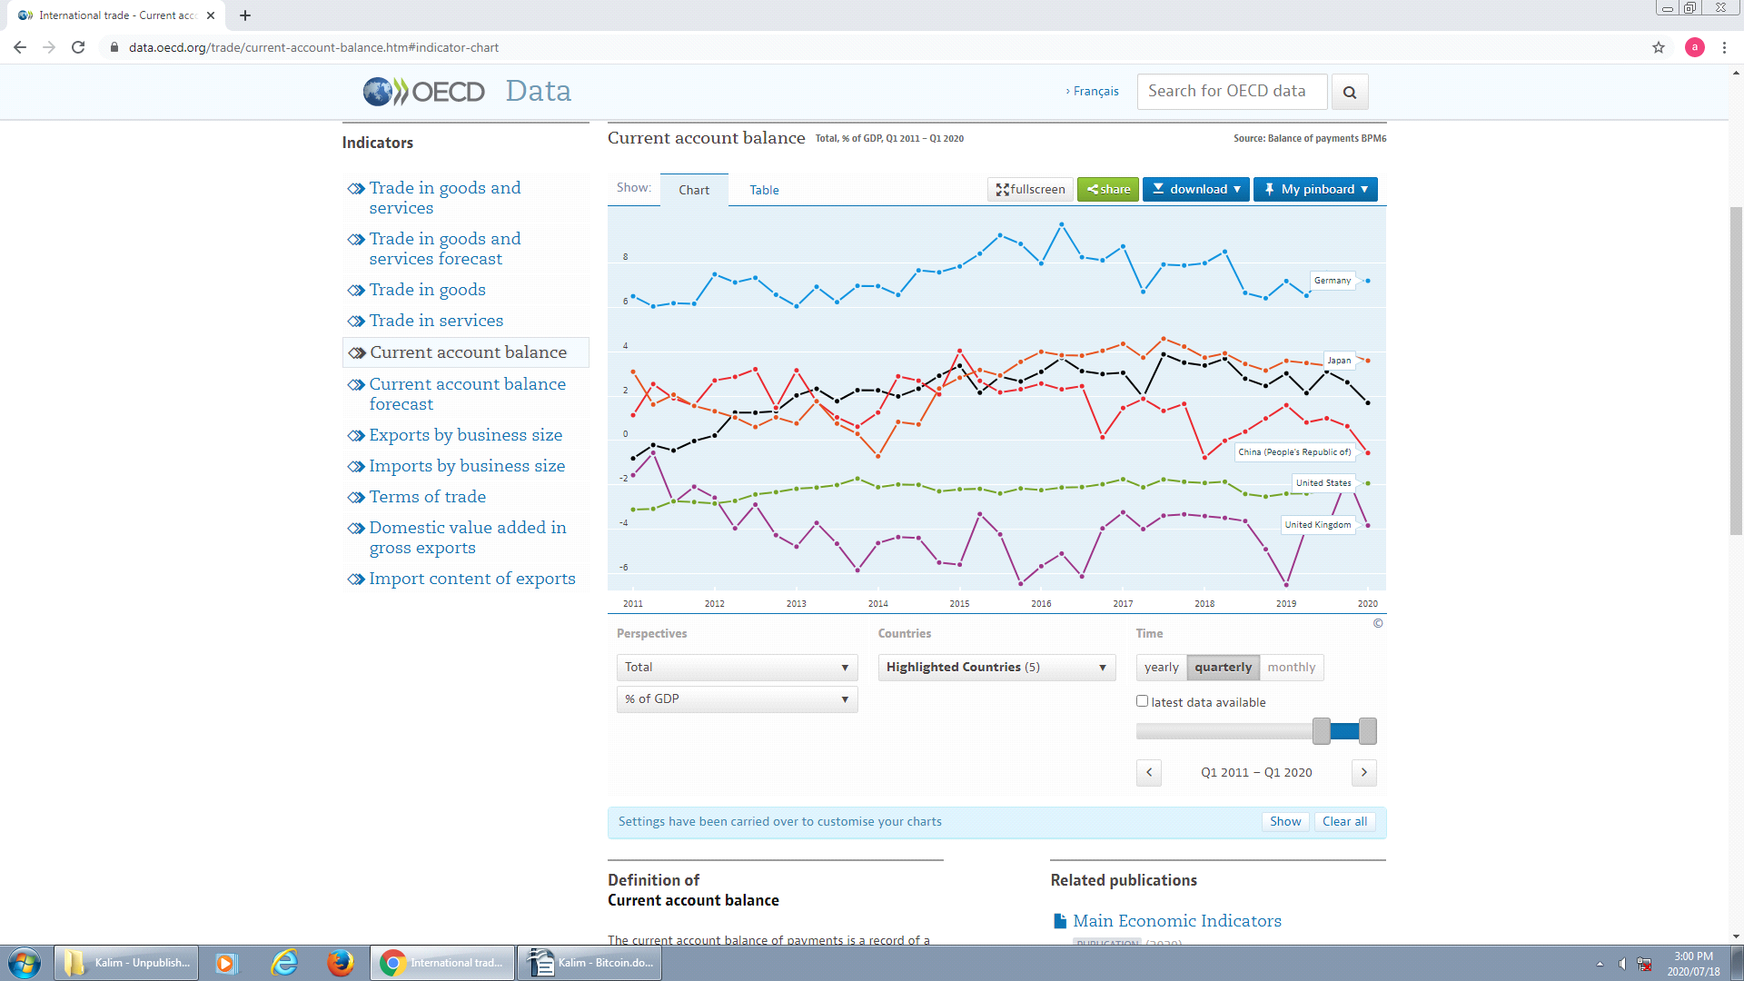

Source: OECD. (Accessed on 18 July 2020)
https://data.oecd.org/trade/current-account-balance.htm#indicator-chart

Source: OECD. (Accessed on 18 July 2020)
https://data.oecd.org/trade/current-account-balance.htm#indicator-chart

Figure 2: Trade in Goods and Services, Exports as % of GDP, 1991-2019.
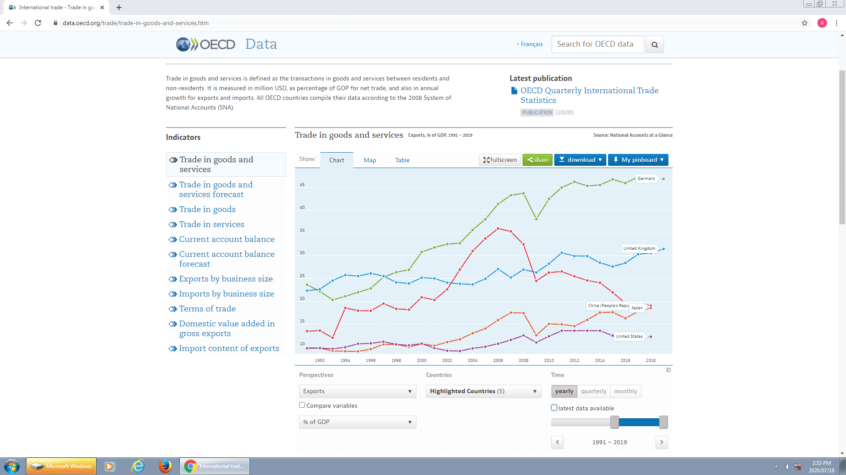

Source: OECD. (Accessed on 18 July 2020)
https://data.oecd.org/trade/trade-in-goods-and-services.htm#indicator-chart

Figure 3: Trends in United States’ External Payments ($ billions), 1970-2017.
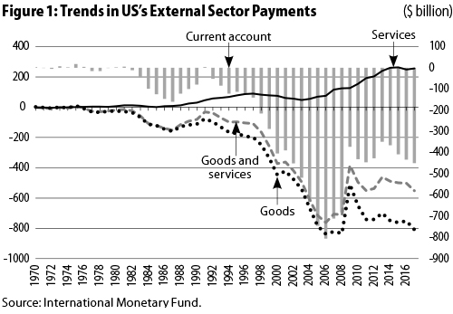

Source: International Monetary Fund (IMF), 2018.

Figure 4: United States – China Trade in Goods (1985-2017)
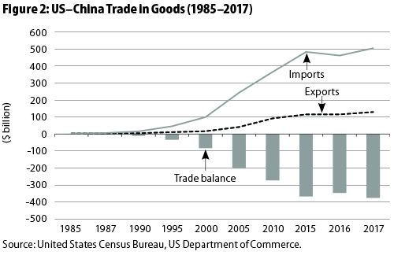

Source: US Census Bureau, US Department of Commerce. 2018.

Figure 5: United States’ Trade Deficit with all Trading Partners, 1985-2017.

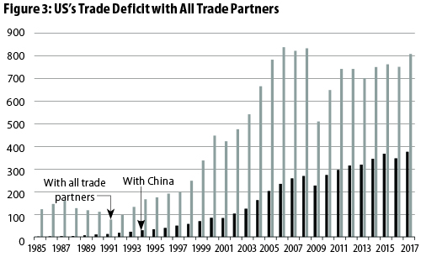
Source: US Census Bureau, US Department of Commerce. 2018.

Figure 6: Annual Growth of the GDP in Major Advanced Economies.
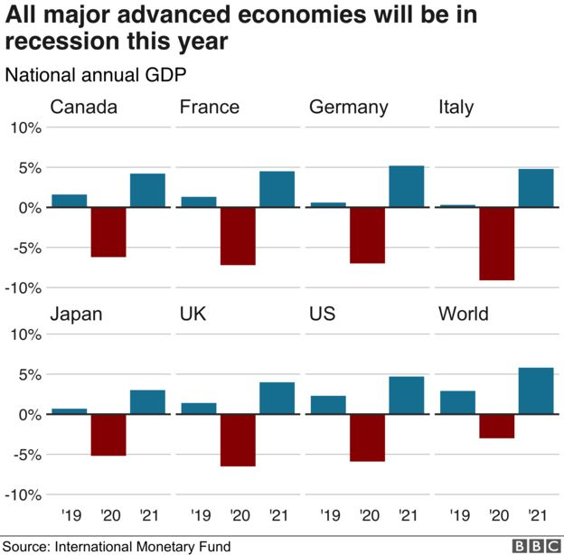
Source: IMF, https://www.bbc.co.uk/news/topics/c77jz3mdmxxt/international-monetary-fund-imf (Accessed on 12th May 2020).
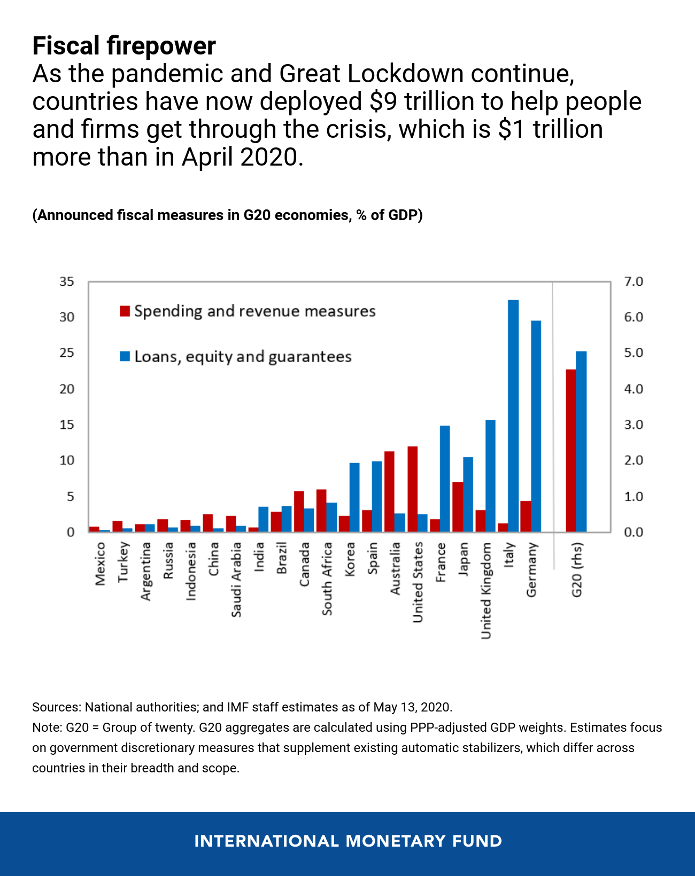
Figure 7: Fiscal Measures Announced in G20 Economies, % of GDP.

Source: IMF, 2020. https://outlook.office365.com/mail/inbox/id/(Accessed on 22 May 2020)

